1st March 2023 …………………………………………………………………….……….…..…….…………..…… Lesson: # 42
B2/C1 levell..
analysis, capacity, passionate, distinctive, superficial, hypothetical, disadvantage,
luxurious, perplexed, reluctant, gullible, ambiguous, introduce, recommend,
revolutionary, extraordinary, deteriorate.

Idioms
cut to the chase, call it a day, put smt on the back burner, be over the moon,
make ends meet, a storm in a teacup, cut corners, get cold feet.

Collocations
Match the nouns with the adjectives – there is TWO word you do not need.
accent, expectation, estimate, surface, traffic, pressure, problem, evidence, idea, timetable
rough | heavy | great | strong

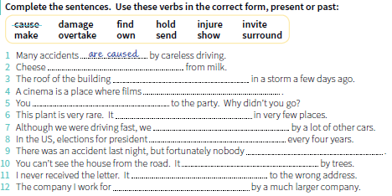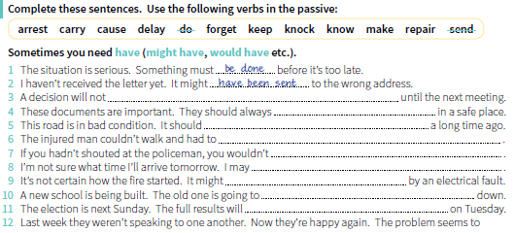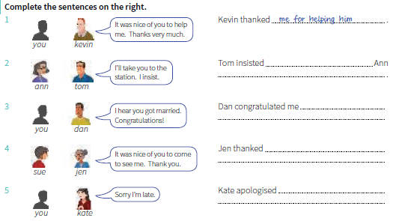
Addiction to Social Media
You know exams are around the corner and you can’t stop checking your Facebook? If that is 1 , you are 2 to get bad results because of your more than apparent internet addiction.
3 can be considered an internet addict when the internet becomes a priority in life, above other priorities, such as exams.
Social media is known 4 a rush of happiness and contentment 5 the release of dopamine, a neurotransmitter which helps control the brain’s reward and pleasure centers, and which plays a key role in addictions. The more people use social media, 6 stimulation they receive, which makes them more vulnerable to addiction.
And teens get more easily addicted to the internet and social media because their brains are still developing and they still have to set their priorities, and that makes it more difficult 7 control their use of social media even when they know that they really need to study for exams.
Social media is a constant source of text, photographs, videos – all of 8 provide stimulus to the brain making the activity addictive. And peer pressure also adds to it, because teenagers feel that they would miss out on what’s going on among their friends if they 9 constantly check their Instagram, WhatsApp or Facebook.
10 seems that addiction to social media is more common in teens with lower self-esteem, 11 their online interactions make them 12 they are part of a group.
Of course, parents on 13 don’t have a clue what their kids do online. Not only 14 have little or no idea how to technically control their children’s behaviour online, but they also have the added problem that teenagers are absolute experts 15 concealing everything from their parents.

The Bermuda Triangle
The Bermuda Triangle occupies a disturbing and almost unbelievable place in the world's catalog of unexplained mysteries. More than a hundred planes and ships have vanished in this area into the air since 1945, and more than a thousand lives have been lost, without a single body or even a piece wreckage from the vanishing planes or ships having been found. Many of the planes concerned have vanished while in normal radio contact with their base until the very moment of their disappearance, while others have radioed the most extraordinary messages, implying that they could not get their instruments to function, that their compasses were spinning, that the sky had turned yellow and hazy on a clear day, and the ocean, which was calm nearby, didn't look right without further clarification of what was wrong.

Nature vs Nurture
People have wondered for a long time how their personalities and behaviors are formed. Two distinct schools of thought on the matter have developed. The two approaches are very different from one another. The controversy is often referred to as nature and nurture. Those who support the nature side of the conflict believe that our personalities and behavior patterns are largely determined by biological and genetic factors. That our environment has little to do with our abilities, characteristics, and behavior is central to this theory. Proponents of the nurture theory claim that our environment is more important than our biologically based instinct in determining how we will act. They see humans as beings whose behavior is almost completely shaped by their surroundings. Neither of these theories can yet fully explain human behavior. In fact, it is quite likely that the key to our behavior lies somewhere between these two extremes. That the controversy will continue for a long time is certain.

